# **Cervical Cancer MRI classification with CNN Report**

## **Topic:**

Image Classification with Convolutional Neural Network

## **Background**

Cervical cancer is one of the most popular cancer for woman, which can be easy prevent if caught in its pre-cancerous stage and have the right treatment. The treatment highly depends on the type of cervical cancer.

Normally, there are three types of cervical cancer, which can be identified by the MRI images. The following are three different types of cervical cancer MRI images.

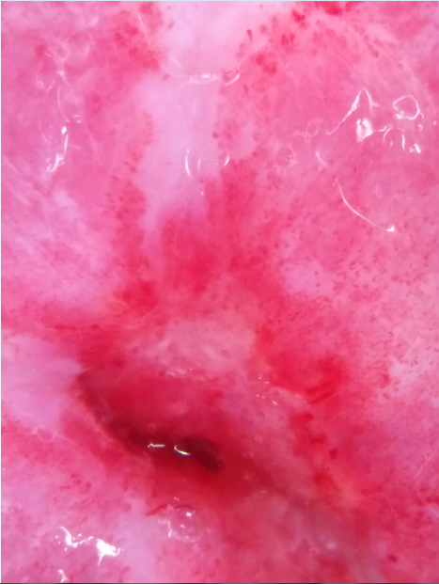 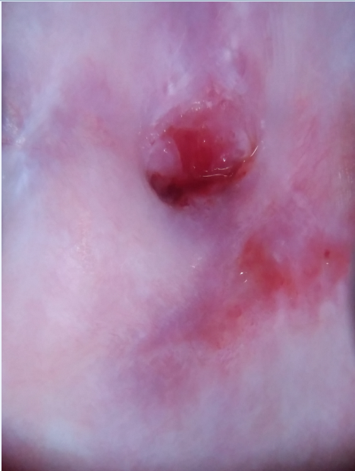 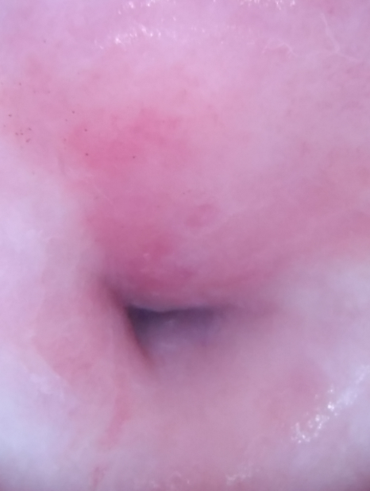

Image 1. Type 1 Image2. Type 2 Image3. Type 3

To better understand the three types. Figure1 shows more details of the difference.

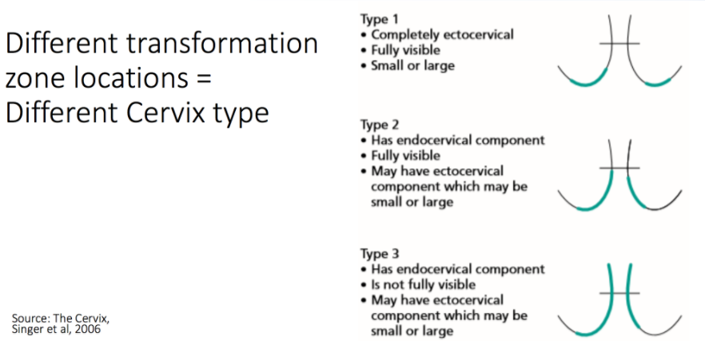

Figure 1. Cervix types

## **Dataset**

In this research, I use Cervical Cancer MRI images, which I download from Kaggle website.

There are three types of Cervical Cancers with 1480 MRI images, which original images is 3096 by 4128 pixels for each image. In order to train these images on Tensorflow, I resized all these original images into 58 by 58, 112 by 112, and 224 by 224 pixels, stored them into one datafile (train.npy). For example, image 4 and image 5.

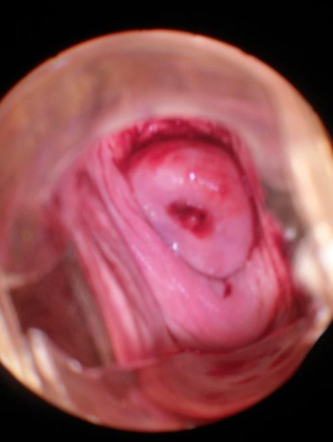 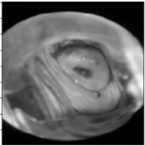

Image 4. Original Image Image 5. Resized image (gray)

## **Algorithms and Results**

I use Tensorflow to build up the convolutional neural network to train the dataset on Amazon AWS (p2.8xlarge).

Before training, I split the dataset into training dataset, which has 1280 images, and testing(validation) dataset, which has 200 images. Then I normalize the dataset.

After prepared all the dataset, I input the train dataset to the convolutional neural network structure. Example: Figure 2. The results in table 1.



Full Connect2

Full Connect1

Max Pooling

Cov2 + ReLu

Max Pooling

Cov1 + ReLu

Figure 2. CNN Structure

|  |  |  |  |  |
| --- | --- | --- | --- | --- |
| **Data Size** | **CNN Structure** | **Keep Property** | **Steps** | **Testing Accuracy** |
| 56 x 56 | Cov1+ReLu: 32 filters 10x10  MaxPool: 4x4  Cov2+ReLu: 64 filters 6x6  MaxPool: 4x4  Fully Connected: 1024 | 0.75 | 2000 | 0.4833 |
| 4000 | 0.4854 |
| 112x112 | 10000 | 0.4708 |
| 224x224 | Cov1+ReLu: 64 filters 3x3  Cov1+ReLu: 64 filters 3x3  MaxPool: 2x2  Cov2+ReLu: 128 filters 3x3  Cov2+ReLu: 128 filters 3x3  MaxPool: 2x2  Cov3+ReLu: 256 filters 3x3  Cov3+ReLu: 256 filters 3x3  Cov3+ReLu: 256 filters 3x3  MaxPool: 2x2  Cov4+ReLu: 256 filters 3x3  Cov4+ReLu: 256 filters 3x3  Cov4+ReLu: 256 filters 3x3  MaxPool: 2x2  Cov5+ReLu: 512 filters 3x3  Cov5+ReLu: 512 filters 3x3  Cov5+ReLu: 512 filters 3x3  MaxPool: 2x2  Fully Connected1: 4096  Fully Connected2: 4096 | 4000 | 0.5270 |
| Cov1+ReLu: 64 filters 3x3  Cov1+ReLu: 64 filters 3x3  MaxPool: 2x2  Cov2+ReLu: 128 filters 3x3  Cov2+ReLu: 128 filters 3x3  MaxPool: 2x2  Cov3+ReLu: 256 filters 3x3  Cov3+ReLu: 256 filters 3x3  Cov3+ReLu: 256 filters 3x3  MaxPool: 2x2  Cov4+ReLu: 256 filters 3x3  Cov4+ReLu: 256 filters 3x3  Cov4+ReLu: 256 filters 3x3  MaxPool: 2x2  Cov5+ReLu: 512 filters 3x3  Cov5+ReLu: 512 filters 3x3  Cov5+ReLu: 512 filters 3x3  MaxPool: 2x2  Fully Connected1: 4096  Fully Connected2: 2048  Fully Connected3: 1024  Fully Connected4: 512  Fully Connected5: 128 | 0.5354 |
| 0.90 | 0.5375 |
| 0.95 | 0.54375 |
| 0.99 | 0.55 |

Table 1. results

## **Problems**

From the results, the accuracy is not satisfied, which highest is 0.55. There are two main problems for this dataset, compare to other image classification project:

1. Color is major subject to identify different images, NOT shape or contour;
2. Lots of cervical MRI images are taken with tools used. For example, image 6.

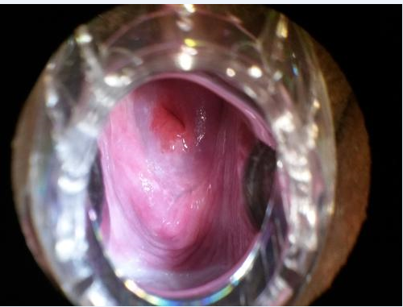 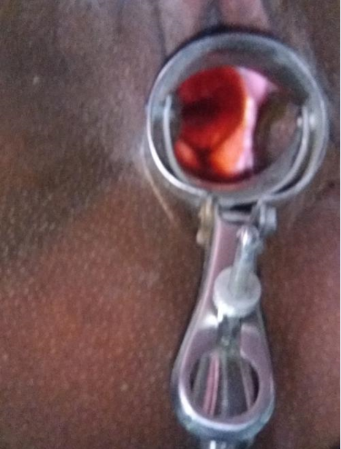 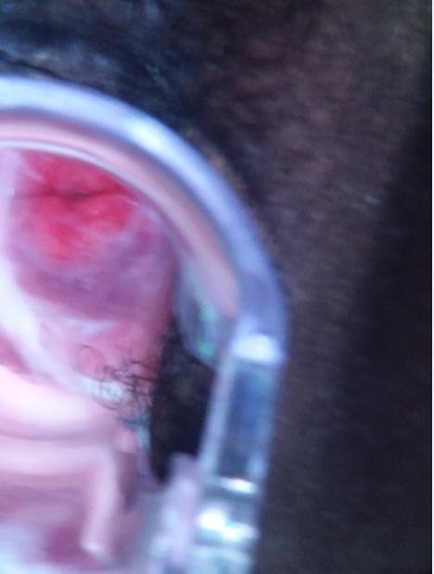

Image 6. Noises

1. There are only 1480 images for the whole project, which is very small.

## **Improvements**

According to the problems, we can improve it in the following methods:

1. Use the original image as the train dataset, which will need lots of resources and train in a long time. At the same time, increasing CNN structure with more hidden layers and neurons
2. Using image processing methods to remove the tools that include in the image before training, or using better MRI images which not contain the tools.
3. Asking for hospital to provide more images for training.